|  |  |  |  |
| --- | --- | --- | --- |
| **Instructor** |  | **Due Date** |  |

**Review of HTML Web Page Design ( 100 points )**

**PROJECT ONE - Review of HTML Form Design**

***PROJECT DESCRIPTION***

Create a Web page using Notepad, according to the following instructions.

***Information about This Project***

A Web page is easily designed using the HTML editor included within Notepad.

***Steps to Complete This Project***

**STEP 1**  **Open Notepad on Your Computer**

Launch Notepad. Open a new text file and save it to your Desktop as: **forms.html**

**STEP 2**  **Design the Required Web Page**

Begin typing the lines of HTML code / tags listed below. Replace your own name in place of Sammy Student.

**Figure 1 HTML Source Code**

|  |
| --- |
|  |

|  |
| --- |
| **<!DOCTYPE html>**  **<html xmlns="http://www.w3.org/1999/xhtml">**  **<!-- Sammy Student: Web Programmer -->**  **<head>**  **<title>Welcome</title>**  **</head>**  **<body style = "background-color:lightgreen;  font-family:tahoma;">**  **<form name = "form1"> [First Name]<br /> <input type = "text" name = "firstname" /> <br /> [Last Name]<br /> <input type = "text" name = "lastname" /> </form>**  **</body>**  **</html>** |

|  |
| --- |
|  |

After you end your Web page code by typing the closing **</html>** tag, save your completed Web page.

**STEP 3 Preview Your Web Page**

Preview your Web page to ensure that your HTML source code correctly displays the page. To do this, leave Notepad open and navigate to your computer’s Desktop. Locate the Web page entitled **forms.html** on your Desktop and double - click the file to view it in your Web browser.

Your Web page now appears within Internet Explorer, as shown below.

**PROJECT ONE**

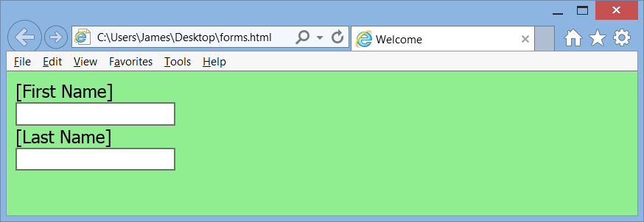

View the page and return to Notepad .

**STEP 4 Modify Your Web Page**

Once you have verified that your Web page is displayed properly within your Web browser, return to Notepad and modify your Web page by adding the HTML code shown within the comments statements below. Place the code within your **<form>** ... **</form>** tags.

**Figure 2 HTML Source Code**

|  |
| --- |
|  |

|  |
| --- |
| **<br />**  **<input type = "radio" name = "sports" value = "bears" checked>**  **Bears <br /> <input type = "radio" name = "sports" value = "lions">**  **Lions** |

|  |
| --- |
|  |

The supplemental new code is to be inserted just before the closing **</form>**

tag. Note these HTML tags are not case sensitive.

After you type the additional HTML code, save your completed Web page.

**STEP 5 Preview Your Modified Web Page**

Preview your Web page to ensure that your HTML source code correctly displays the page. To do this, leave Notepad open and navigate to your computer’s Desktop. Locate the Web page on your Desktop and double - click the file to view it in your Web browser.

**STEP 6 Include Some Checkboxes**

Supplement your HTML form design by using four checkboxes. You can continue with the theme / subject matter of the two sample checkboxes given below.

**PROJECT ONE**

**Figure 3 HTML Source Code**

|  |
| --- |
|  |

|  |
| --- |
| **<br />**  **<input type = "checkbox" name = "vehicles" value = "bicycle">**  **I prefer traveling with a bicycle.**  **.**  **.**  **.**  **<input type = "checkbox" name = "vehicles" value = "auto">**  **I have an automobile** |

|  |
| --- |
|  |

**STEP 7 Include a Drop - Down List**

Supplement again your HTML form design by using six drop - down list items. You can continue with the theme / subject matter of the three sample drop - down list items given below.

**Figure 4 HTML Source Code**

|  |
| --- |
|  |

|  |
| --- |
| **<br />**  **<select name = "movies">**  **<option value = "action">Action</option>**  **<option value = "adventure">Adventure</option>**  **.**  **.**  **.**  **<option value = "comedy">Comedy</option>**  **</select>** |

|  |
| --- |
|  |

**STEP 8 Include a Text Area**

Supplement again your HTML form design by adding a text area.

**Figure 5 HTML Source Code**

|  |
| --- |
|  |

|  |
| --- |
| **<br />Your Comments**  **<textarea name = "message" rows = "5" cols = "40"> We value your remarks. </textarea>** |

|  |
| --- |
|  |

**PROJECT ONE**

**STEP 9 Include a Submit Button**

Supplement again your HTML form design by adding a submit button before the closing **</form>** tag.

**Figure 6 HTML Source Code**

|  |
| --- |
|  |

|  |
| --- |
| **<input type = "button" value = "Submit" onclick = "Go();" />** |

|  |
| --- |
|  |

**STEP 10 Save and Test Your Web Page**

Save and view your Web page in MS Internet Explorer.

**STEP 11 Add Interactive Effect to the Web Page**

Return to Notepad and add a **<script>** tag pair to the **<head>** and, within the script tags, define a function that performs some tasks.

**Figure 7 HTML Source Code**

|  |
| --- |
|  |

|  |
| --- |
| **function Go()**  **{**  **var myFName = "";**  **var myLName = "";**  **var message = "";**  **myFName = document.form1.firstname.value;**  **myLName = document.form1.lastname.value;**  **message += myFName + " " + myLName;**  **window.alert("welcome: " + message);**  **return true;**  **}** |

|  |
| --- |
|  |

**STEP 12 Add a Table and an Image to the Web Page**

Save your Web page and then use a **<table>** tag pair to add a one row and one column table to the page, directly below your form data.

Within the one row - one column table, insert an image that complements your Web page. You can use MS Paint to create your own image.

**STEP 13 Review, Save and View Your Web Page**

After you design your Web page, review the page for the following characteristics:

• ensure that form elements, images are spaced professionally

• ensure that form elements are functional

**PROJECT ONE**

• ensure that any scripts are performing properly

After you review and test your Web page, submit the HTML source code and screen snapshots in an MS Word document and submit the document for credit.